**Using loc, iloc and ix**

There are three ways to select data from a data frame in Pandas: *loc*, *iloc*, and *ix*.

**loc**

*loc* is primarily label based; when two arguments are used, you use column headers and row indexes to select the data you want. *loc* can also take an integer as a row or column number.

Examples of *loc* usage:

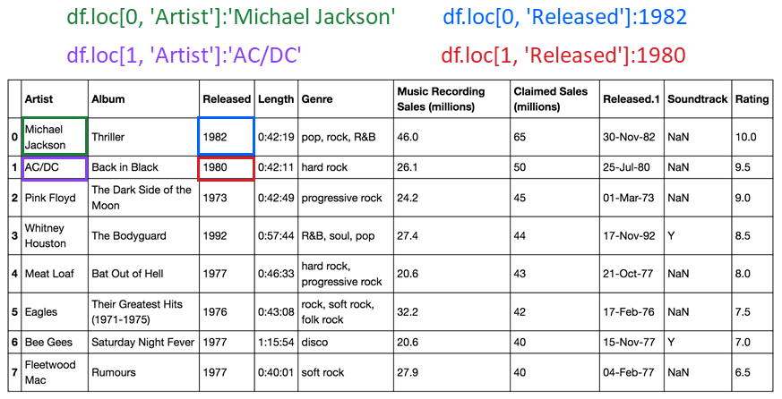

*loc* will return a *KeyError* if the requested items are not found.

**iloc**

*iloc* is integer-based. You use column numbers and row numbers to get rows or columns at particular positions in the data frame.

Examples of *iloc* usage:

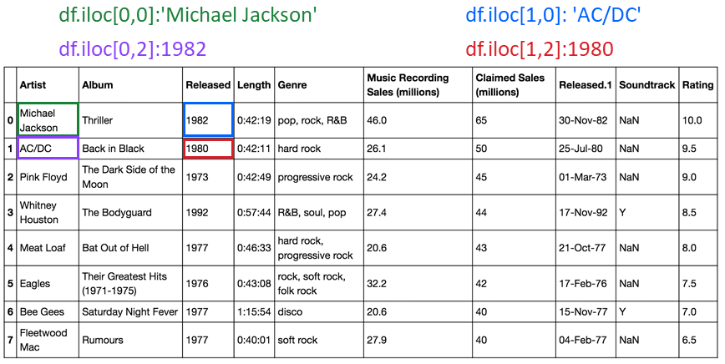

*iloc* will return an *IndexError* if the requested indexer is out-of-bounds.

**ix**

By default, *ix* looks for a label. If ix doesn't find a label, it will use an integer. This means you can select data by using either column numbers and row numbers or column headers and row names using *ix*.

In Pandas version 0.20.0 and later, *ix* is deprecated.

**Using loc and iloc for slicing**

You can also use *loc* and *iloc* to slice data frames and assign the values to a new data frame.

**Creating a new dataframe with loc slicing**

You can also slice data frames and assign the values to a new data frame using the column names. The code assigns the first three rows and all columns in between to the columns named Artist and Released. The result is a new data frame Z with the corresponding values.

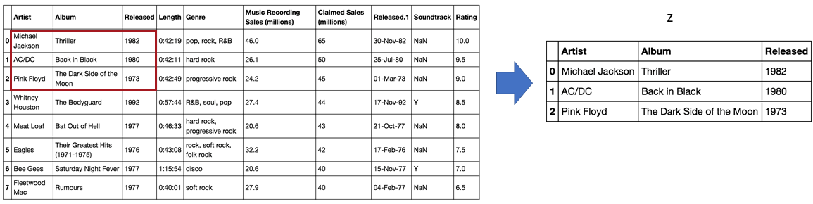

**Creating a new dataframe with iloc slicing**

In this example, we assign the first two rows and the first three columns to the variable Z. The result is a data frame comprised of the selected rows and columns.

